05-06-02

COMPLETE TUTORIAL FOR TRANSFERRING MUSIC FROM YOUR DIGITAL INSTRUMENT AND BURNING IT TO CD

This training package was written by Carol Dooley (Sissle@aol.com), however I couldn’t have done it without the help of Shirley Warwick, Alec Pagdia and Gunnar Jonny. They are the ones who so diligently shared their knowledge and expertise with me so that I could record my music. The credit actually goes to them. My only accomplishment was to take the information that they provided and write it up so that we may all understand the process. This package is my “Thank You” to them for their willingness to share their vast knowledge. I feel fortunate to have them as my friends.
TRANSFERRING MUSIC FROM YOUR DIGITAL PIANO AND BURNING IT TO CD

This training is going to give you the basics of how to transfer your music from your Technics digital piano to your computer and how to get it from your computer onto a CD. There will be many features that I will not touch on, such as editing your music while it is in the computer and the different methods of burning a CD. This will be strictly a reference to get you started on the right track. Adaptec CD Creator and Cakewalk Pro Audio 9 are the software programs that I would recommend you use. An excellent book for help with Cakewalk Pro Audio 9 is “Cakewalk Power” by Scott R. Garrigus. It is easy to understand, and covers all of the aspects of using Pro Audio 9, creating music files, editing those files, converting files so your CD burner can read them and how to burn to CD. The information covers Audio files, MIDI files and combination Audio and MIDI files. Adaptec Easy CD Creator contains enough information in the HELP feature of the program to more than satisfy your needs.

Burning music to a CD that comes from your digital piano is not as simple as burning music from MP3 files that you have downloaded from the Internet or music taken directly from a commercially sold music CD. The files created on your piano must be in the proper format for your CD burner to understand them and they must be recorded at appropriate recording levels to eliminate distortion.

What type of gear do I need to get started?

- One stereo Audio Cable to connect your piano to your computer.
- A CD burner – internal or external. (We use external for this training.)
- Software – Cakewalk Pro Audio 9 or similar quality and the CD burning software that comes with your burner. Most come with Adaptec Easy CD Creator.
- Blank CD’s for recording music.

Another important factor is buying the correct type of blank CD. There are two types of blank CD’s on the market. One is the CD-R and the other is the CD-RW. The CD-R stands for READ. The CD-RW stands for READ & WRITE. See the table on the next page for advantages and disadvantages of each type of blank disk.

QUESTION: | CD-R | CD-RW | COMMENTS
Can I record music on this  type of disk? | Yes | Yes | Either disk will record music.
Can I erase music on this  type of disk or re-arrange  the order of the music? | No | Yes | A CD-RW disk allows you to erase or re-arrange your music that has been recorded. A CD-R disk means your recording is permanent. There are no second chances.
Can I play this disk  in my CD player or home/car stereo? | Yes | Seldom | Most CD players are NOT compatible with CD-RW disks. However, CD-RW disks can be played or read by your computer. CD-R disks are compatible with most CD players and will work in all computers with a CD ROM drive.
Some blank CD’s are 74 minutes long and others are 80 minutes. Do both work for music or data? | Yes | Yes | Both work just the same way. The only difference is the length of recording time. Buy either.
Which type disk is best to use  To back-up my data files? (Such as financial records, Word documents, Excel documents, etc.) |  | X | Files generally change as you add to them or change figures in them. Therefore, it is best to use CD-RW so you can overwrite the old files.
Can I save data such as Word or Excel documents on this type of disk? | Yes | Yes | Either type CD is capable of recording documents or digital signals.
There are so many different brands, can you recommend any particular one? | X | X | I use Memorex recordable MUSIC CD-R in the 80 minute length. Stick with a brand name. You will find an occasional dud no matter which brand you use.

As you can see from the chart above, the best choice for recording your music to CD is the CD-R disk. Use the CD-RW disks for backing up your computer data that you don’t wish to loose if your computer crashes.

Another important bit of information is that the Technics digital piano’s do not send MIDI data to your computer for any rhythm you use without first converting every instrument in the rhythm into a separate track and assign it an acceptable MIDI instrument. Therefore, it is important to remember that the easy way to capture songs utilizing rhythms is to record your music as an Audio file, not a MIDI file.

LET’S BEGIN THE RECORDING PROCESS!

For the purpose of this training, I am going to assume that you have recorded enough of your music to disk so it is just a matter of loading it into your piano’s memory to record it.

SETUP:
The first thing we need to do is set up our piano, computer and CD burner if it is external. Before turning your computer or your piano on, connect all of your equipment.

- Plug the double end of your Stereo Audio cord into the back of your piano. One plug goes into the LINE OUT (R) socket, and the other plug goes into the LINE OUT (L) socket.

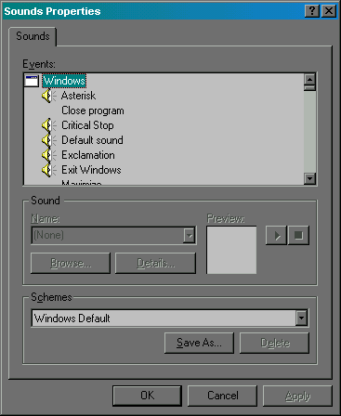
- Now plug the single end of your Stereo Audio cord into your laptop computer in the socket for your sound card. It usually is on the left side and has a picture of a bell surrounded by sound waves. Looks like this: ((( )))

- There is no need to change the setting on the back of your piano from MIDI to PC2 for recording Audio files. This is a completely different setup than recording MIDI data.

- Now plug your external CD burner into the computer using the USB cable. The USB port is usually on the left side of your laptop. There are two USB ports. They look like 1/2 inch long slots – one on top of the other. It should go in easily. If it doesn’t, you probably have it upside down and need to turn it over first.

- The other end of the USB cable is a longer pin type connector. Plug it into the CD Burner receptacle labeled COMPUTER. (Or if not labeled, the one that matches the size of the connector.)

- Now plug your power cord into the CD Burner and into your electrical outlet. Make sure your CD Burner has power. To do this, push the button to open the door to the CD tray. If it opens, you have power.

- Now turn on your piano.

- Last, but not least, turn on your computer.

SETTING UP PRO AUDIO 9 TO RECORD YOUR MUSIC:

- Open your Pro Audio 9 software program.
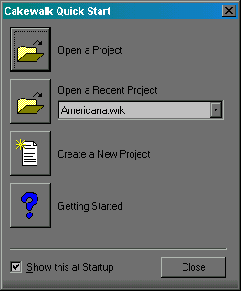
- Close the Tip Of The Day box that comes up automatically.

- Now the Cakewalk Quick Start box pops up. Select “Create A New Project”

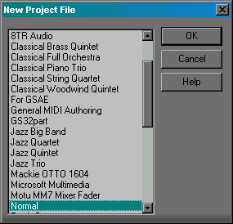
- Next the New Project File box comes up. The project type “Normal” is usually highlighted. If it isn’t, highlight it by clicking on the word Normal and then click the OK button. Your new recording track is ready for you to make any necessary changes before recording.

THIS NEXT STEP IS VERY IMPORTANT! USUALLY YOU JUST HAVE TO CHECK IT ONCE PER RECORDING SESSION TO BE ON THE SAFE SIDE. IT IS THE DEFAULT SETTING FOR ALL NEW PROJECTS AND SHOULDN’T CHANGE UNLESS YOU MANUALLY CHANGE IT.

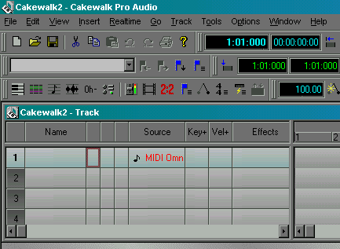
- To store music on a CD, the audio data is required to have a sampling rate of 44,100 Hz and a bit depth of 16 bits. These values can not be higher or lower. They must be exact! To make sure this setting is accurate, go to the word OPTIONS and click on it. From the drop down box, click on AUDIO.

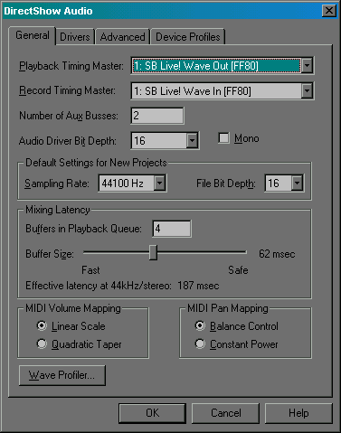
- The DIRECT SHOW AUDIO box pops up. Click on the GENERAL tab. Check that the SAMPLING RATE is 44100Hz. If that isn’t the number in the box, change it to 44100Hz. Next check to make sure that the FILE BIT DEPTH is set to 16. If the number does not read 16, change it to 16. When the sampling rate and bit depth are set correctly, Click the OK button.

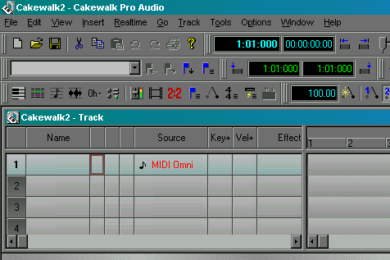
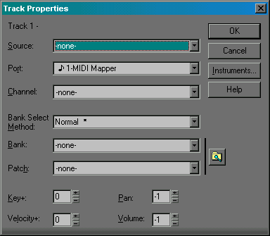
- Now take a look at track 1 in Pro Audio 9. Notice that the SOURCE column says MIDI OMNI. We can not leave it like that or we will never record our Audio data to the track. Double click on the word MIDI OMNI. This opens up the box called TRACK PROPERTIES. Note that behind SOURCE, it says NONE. Open up the drop-down menu to access the selections by clicking on the drop down arrow at the end of the box. This brings up the options that are available for us to select the source of our Audio. From the selections in the drop down box, click on STEREO SB LIVE! WAVE-IN (FF80). (Or, if you have a different sound card, click on the name of your sound card that says stereo in it.) This replaces the NONE with our sound card data. Click OK.
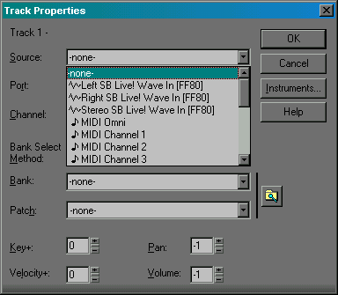
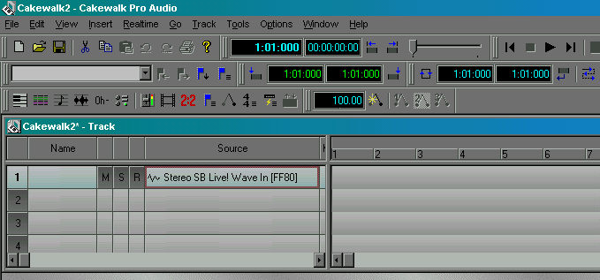
- Now the SOURCE column in our track reads STEREO SB LIVE! WAVE-IN (FF80) instead of MIDI OMNI. This is the correct selection for recording Audio tracks.

SETTING UP THE SOUND CARD:

Our next step is to set up our sound card in our computer for recording into our track.

- Find the START toolbar at the very bottom of your computerscreen. Find the (ICON) of the bell that you normally use to set the volume of your sound on your computer. If you single click it, the volume slider pops up where you can adjust your volume. Don’t single click it. Double click it instead. This should bring up a box called PLAY CONTROL.

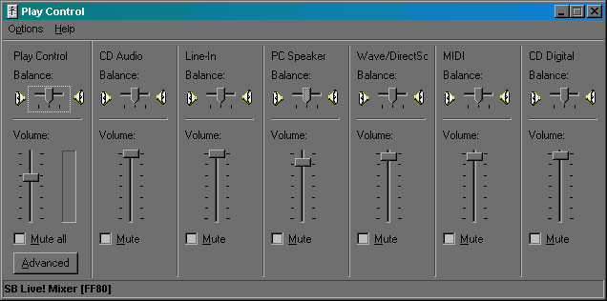
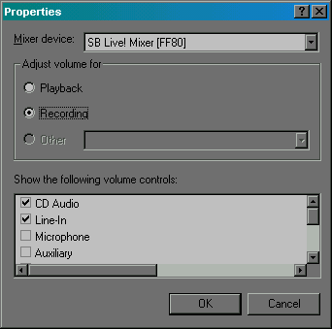
- In the PLAY CONTROL box, find the word OPTIONS and click once on it. From the drop down box click on the word PROPERTIES. The PROPERTIES dialog box will pop up. We want to adjust our volume for Recording, so we need to click on the little white circle in front of the word Recording to select it. Right below that is a white box that lists all of the volume controls that we can view. Make sure there is a check in the box in front of the one called LINE IN. Now click on OK. When you click on the OK, the RECORD CONTROL box pops up with all of our volume sliders. Remember, the only volume control that is important to see for our recording is the LINE IN volume slider. Another note – all sound cards are not alike, so your sound card may require that you select something different other than LINE-IN. You will have to experiment to find the proper volume control specific to your sound card.

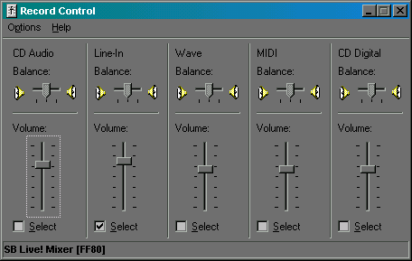
- Your next step is to SELECT the LINE-IN as the volume control for your recording. To do this, click in the square white box in front of the word SELECT for the LINE-IN volume control. This puts a checkmark in the box and tells our computer that this is the volume control we will be using during our recording.

- Do not close the RECORD CONTROL box out. We will need to use it as we set up our proper recording levels.

NOW LET’S TURN OUR ATTENTION TO OUR PIANO:

- From your disk, load the first song that you want on your CD into your piano’s memory.

- Just to make sure it has correctly loaded, push the Start/Stop button to hear the song. Play only enough to know that it is loaded correctly and set your volume controls on your piano for how you want to hear your song. (Do not set it too loud!) Then hit the Fill In 1 button to reset the song back to the beginning.

WE ARE NOW READY TO SET UP CORRECT VOLUMES FOR RECORDING AND FINISH SETTING UP PRO AUDIO TO RECORD OUR FIRST SONG AS AN AUDIO FILE

RECORDING:

Before we begin to record, we need to discuss volume control. If our volume is too high, we end up with distortion in our recording. If it is too low, we have an unsatisfactory performance. So, we need to monitor the Console View in Pro Audio 9 before we do any actual recording to make sure that we do not exceed the proper decibel levels. To bring up the Console View in Pro Audio 9, follow these steps:

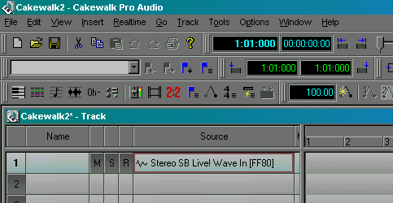
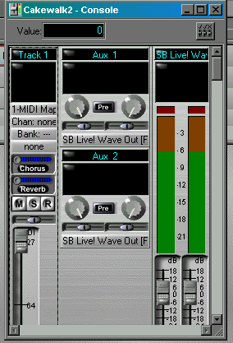
- In Pro Audio 9, Click on the word VIEW to bring up the drop down box. From the drop down box, click on the word CONSOLE. This brings up the CONSOLE VIEW where we can monitor the recording level of our song. The Console View looks like this:

- Now we are going to play our song without recording it and monitor our recording levels in the Console View. We are going to control the volume with our RECORD CONTROL LINE-IN volume slider for our sound card. But first, we need to set up PRO AUDIO 9 so that we can see all of the controls we need to monitor before we begin playing our song.

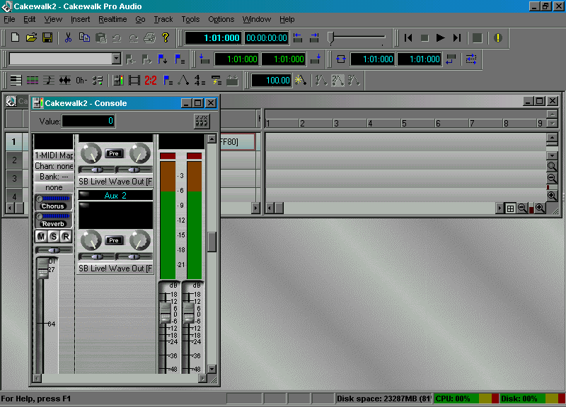
- Here is how I prefer to have my PRO AUDIO set up so I can see all the data I need to watch:
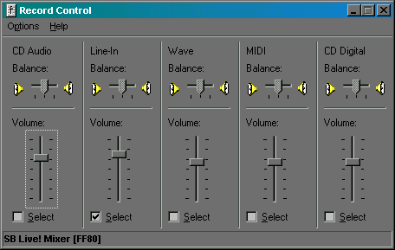
NOTE: Whenever you click on something else on the Pro Audio screen, the RECORD CONTROL box automatically goes behind Pro Audio and hides from view. Just click on the button that says RECORD on your Start Toolbar to bring it back up again! I know, it is frustrating, but we have to live with it!
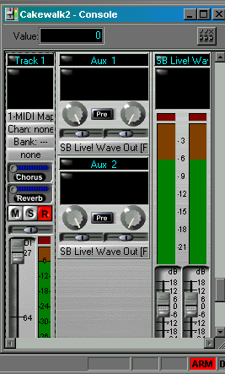
- The meter that you are going to watch as you play your song on the Control Console is this one

- However, before it displays your recording dB levels, you have to arm the track for recording. This can be done in one of two ways. (Don’t worry, arming the track to record will not begin the recording process yet!) Click on the R button to turn it on. It should turn red and the meter will pop up in color on the display. (R stands for Recording)

- One last thing before we start testing our record level. Make sure your RECORD CONTROL panel is displayed so you can change the volume slider as you monitor the meter. Hint: Your screen should be setup similar to the one at the top of the previous page of this training.

- As the song is playing, the Meter for the Track in the Console View will light up, displaying the sound level of your performance. You should adjust the input level so that when you play the loudest part of your performance, the Meter does not turn red. If it turns red, you have overloaded the input, and if you record at that level, your audio signal will be distorted. . If the Meter lights up anywhere between –6dB and –3dB when you play the loudest part of the performance, you have a good input level setting.

- So, where is the –3dB to –6dB level on my meter? See the example below:
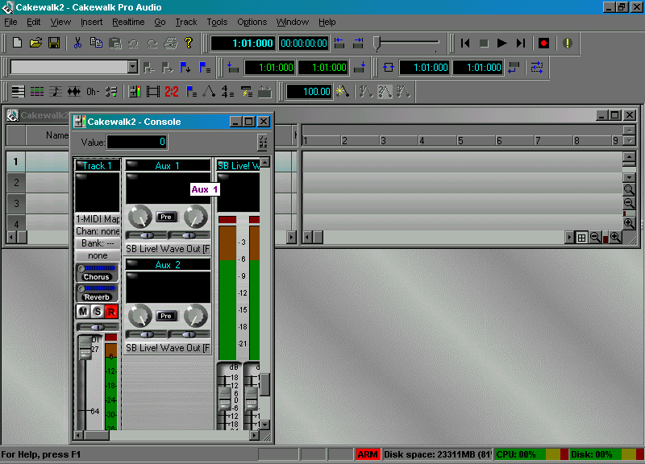

-3dB to –6dB
is between the
Two yellow
Lines.

- Now we can begin our song and watch the recording level. Hit the Start/Stop button on your piano to begin playing the song. Keep your eyes on the meter. The minute it turns the meter red the first time, turn the volume slider down a fraction on the LINE-IN volume control. Keep watching. If it turns the meter red again, nudge the volume control down another fraction. Watch through out the whole song, adjusting the volume control until you no longer see any red.

- Now start your song all over again. Watch the meter again. If it gets into the red again, adjust the volume control down slightly again. Continue on with this process until you no longer have any red when you play the whole song through.

- All the time while you are doing this, remember what I said: You have a good recording if the loudest part of your song is somewhere in the –6dB to –3dB range.

- When you have the volumes set correctly you may close out the RECORD CONTROL window and the CONSOLE VIEW window. If you still want to watch the meter while you record, you can leave the CONSOLE VIEW open.

NOW WE HAVE OUR METERS SET CORRECTLY FOR RECORDING, LET’S RECORD OUR SONG!

Before you start the recording process, make sure that your piano sequencer and your track in Pro Audio 9 are set at the very beginning.

- Press the FILL IN 1 button to reset the piano sequencer.

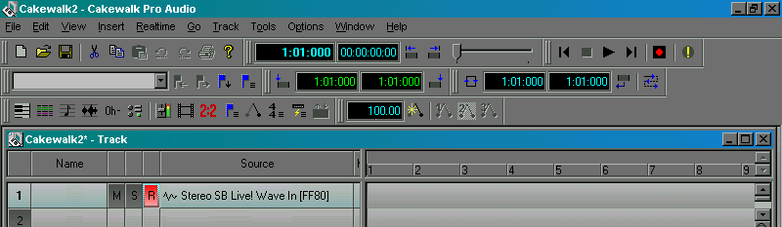
- To set your track to the very beginning, click on the rewind button of the playback/record controls.

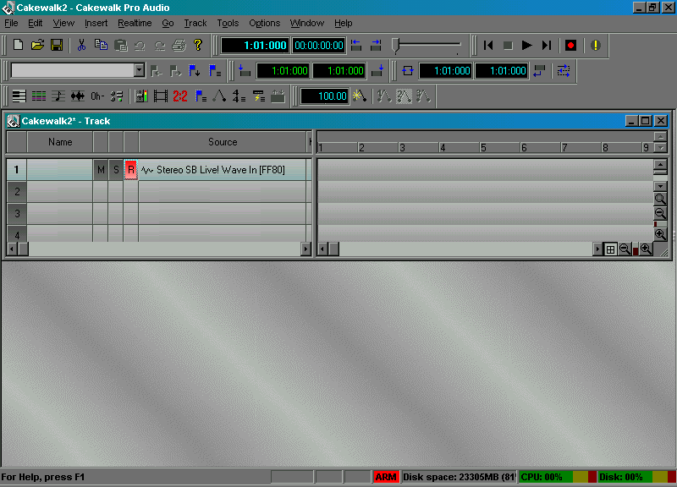
- Now make sure your Pro Audio 9 track is armed for recording. To do this, click on the R button so it is red in color.

- You can also tell that your track is ready for recording because it says ARM in red at the bottom of the screen and the Red record button is lit.

- To begin the recording, press the RED record button first, and then press the START/STOP button on your piano.
- When the song is finished, press the Red Record button to stop recording. (You may press the computer space bar to stop recording.)

- Now playback your song. Click the REWIND button and then the PLAY button to listen to your song.

- You can erase your track and redo it if you do not like it. To erase, just go to the word EDIT and click on it. From the drop down box click on ERASE RECORDING. You can do this as many times as you wish until you are satisfied with the recording.

- Now deactivate the RECORD function by clicking on the red R button. It should turn gray to let you know that you are no longer in the Record mode.

- Now we are ready to save our project. Click on the word FILE. From the drop down box, select SAVE AS. This will bring up the normal window where you can name your newly created file. Go ahead and name it. In the SAVE AS TYPE box, click on the down arrow. From the drop down box choose CAKEWALK BUNDLE. (We save it as a Cakewalk Bundle file because it has to be in an Audio format before we can change it to a .WAV file.)

- As the file saves, you should see a blue bar that shows you the progress of the save function. Within that bar it also tells you it is saving an AUDIO file.

CONVERTING OUR AUDIO FILE INTO A .WAV FILE

Our files can not be laid down as audio tracks on a CD. Therefore, we have to convert them into a file type that our CD Burner understands. If our project contained any MIDI tracks, we would have to convert all of the MIDI tracks into Audio tracks before we could convert the whole file into a .WAV file. However, in this training, we have not created any MIDI tracks in our project, so we can go ahead and convert our project into a .WAV file just the way they are. Following are the steps to convert to .WAV files:

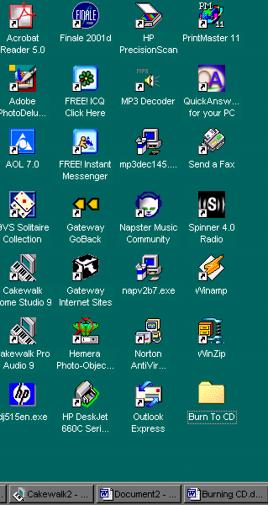
- First of all, we need to create a Folder on our desktop and save our .WAV files into that folder. I suggest doing this because it makes them easy to find when you are looking in your computer for the files to add them to the CD you will be creating. To create a folder, RIGHT click on an empty space of your DESKTOP screen. From the pop-up window, select NEW. A new window pops up. At the very top of this new window is the word FOLDER. Click on it to create the new folder. Now find the new folder on your Desktop. Notice that the name is highlighted and it says ‘new folder”. Because the name is highlighted, I can just begin typing the new name for the folder. Change that name to something that you will easily recognize. I have selected the name “Burn To CD” for my folder.

- Now we can begin converting our file in Pro Audio 9 to a .WAV file.

- Our project needs to be open in Pro Audio 9 before we can do the conversion process. It still should be unless you closed it out after saving it. If you did close it out, bring it back up by clicking on the word FILE. On the drop down box that opens up, the file we just created should be listed. Click on the name of the file to bring it back up on your screen.

- Now click on the word TOOLS in the top menu bar. From the dropdown menu that appears, click on MIXDOWN AUDIO. A new box slide out. From it click on EXPORT TO FILE(S). (Sorry, I can’t show you the slide out box that says EXPORT TO FILES – It won’t stay open for me to take a picture of it, but I think you will muddle through it without my having to show it to you.)

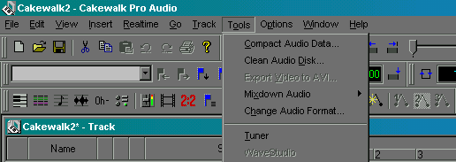

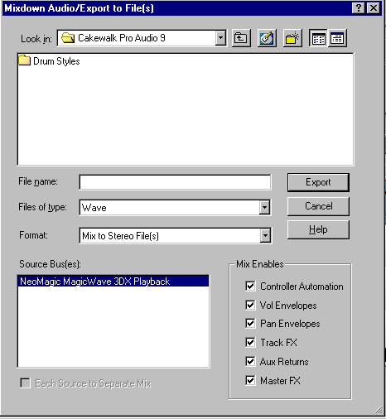
- When you clicked on EXPORT TO FILE(S), it brought up the MIXDOWN AUDIO/EXPORT TO FILE(S) dialog box. It looks like this:

- From the LOOK IN list, click on the down arrow at the end of the box. Click on DESKTOP from the dropdown box.
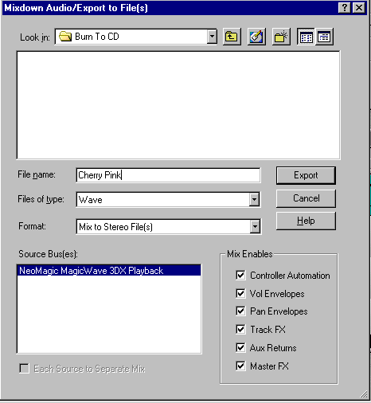
- Double click on the new folder that we have created called “BURN TO CD”. This puts the name of our new folder in the LOOK IN box. Our new file will be saved to that folder.

- Type a NAME for your file in the FILE NAME BOX. (How about the name of the song you are saving?)

- Click on the down arrow for the FILES OF TYPE box. From the drop-down list, click on the WAVE option. This puts the word WAVE in the FILES OF TYPE box.

- In the SOURCE BUS(ES) field, there will be only one sound card listed unless you have multiple sound cards in your computer. We don’t, so we do not have to do anything with this box.

- Leave the EACH SOURCE TO SEPARATE MIX option deactivated. (Please, no check mark in the box!)

- In the MIX ENABLES box, leave all options check marked to ensure that your new .WAV file will sound exactly the same when played back as the original Audio track.

- Click on the EXPORT button, and Pro Audio begins to mix the Audio track into to a new .WAV file.

- When Pro Audio is done mixing, you will have a new file in the folder we created on your Desktop called “Burn To CD”. This will be the file that we will use to burn to our CD.

NOTE: At this point, you may wish to prepare enough songs to fill your CD, or perhaps you would like to burn just this one song. Keep in mind, that if you burn only one song, and you close the CD, that is the only song that will ever be on that CD. Once a CD is closed on a CD-R disk, it can never be written on again! You can burn the one song and not close it and be able to play the CD on your stereo or CD player as long as you choose the correct option when you record. This training will help you choose the correct settings when as we go through the burning process.

ANOTHER NOTE: So you don’t become confused, we talk about closing CD’s and closing recording sessions. They are two different things. Closing a recording session means that you are done recording for that particular layout. Closing a CD means that you are done recording songs to it and are blocking it from any further recording.

THERE, WASN’T THAT EASY? NOW WE ARE READY TO BEGIN BURNING OUR FIRST SONG TO CD.

BURNING FILES TO CD

The first thing we need to do is open up the software for burning our CD’s. Click on the START button. From the pop-up menu, choose PROGRAM. From the next pop-up menu, select ADAPTEC EASY CD CREATOR. From the next pop-up window, click on CREATE CD. This brings up the program that we will use to burn our CD.

- 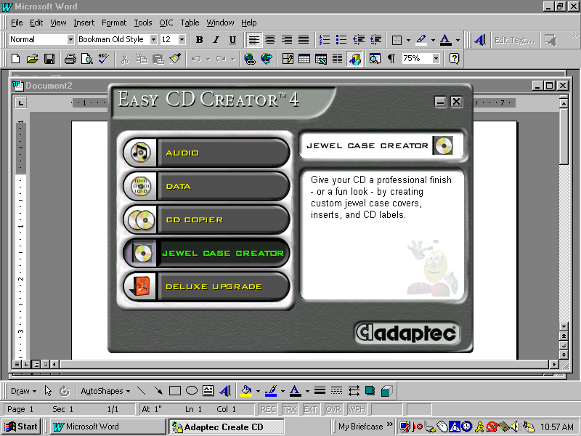The following screen should appear:

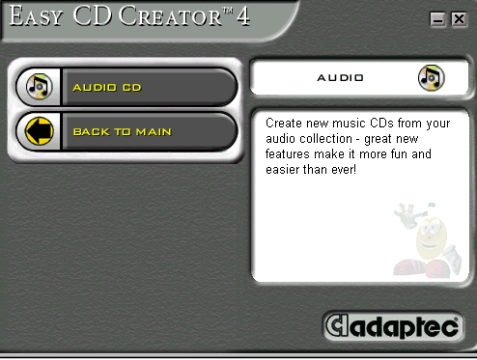
- This screen is where we will select what action we want to perform. Because we are going to burn an Audio file to CD, we will click on the word AUDIO. The following screen pops up where we make our next selection:

- From this pop up window, select AUDIO CD.

- This brings up the window where we will prepare our songs for
recording to CD. See example at top of next page.

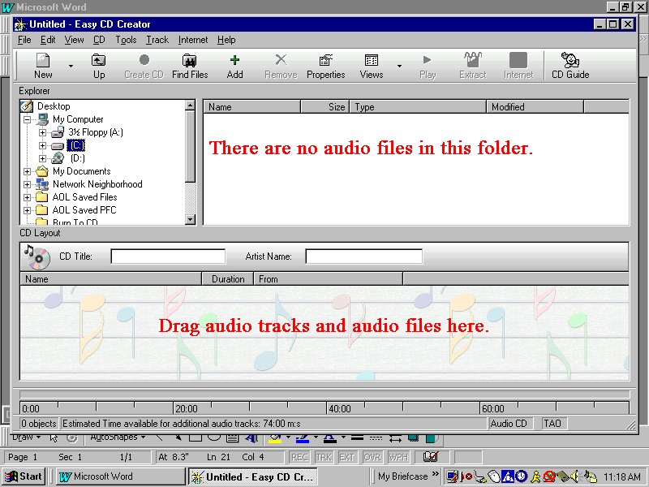
- I suggest using the CD GUIDE to help you work through the process of preparing your music line-up for your CD. In the example above, the GUIDE is not activated. To activate the GUIDE, click on the CD GUIDE button at the top.

- Now your screen should look like this:
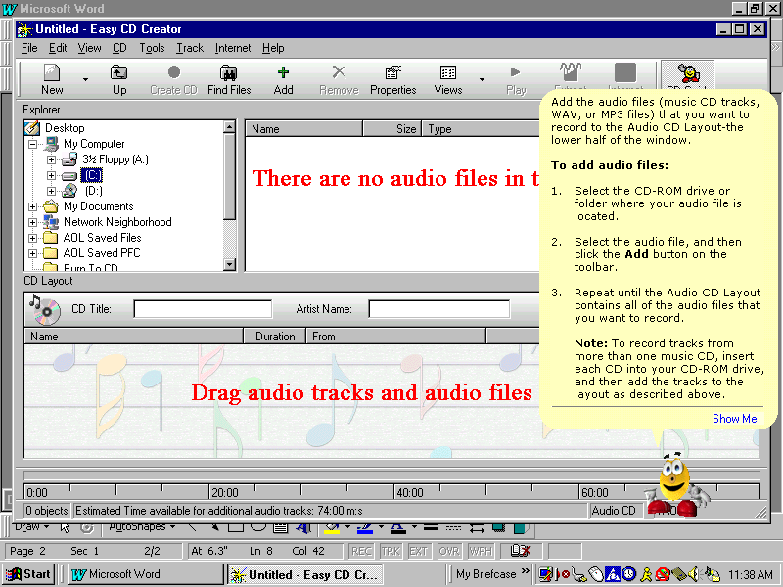

- Our GUIDE gives us all the information that we need to build our music line-up. If you don’t understand the directions, click on SHOW ME and the GUIDE will show you how to do the function.
- The EXPLORER box on the screen is where we are going to tell our program to look for any files that are in the correct format that we could burn to CD. Note that the C DRIVE is highlighted in this snapshot.. Because I have all my files in that new folder that we created on our desktop, I will get the message THERE ARE NO AUDIO FILES IN THIS FOLDER.

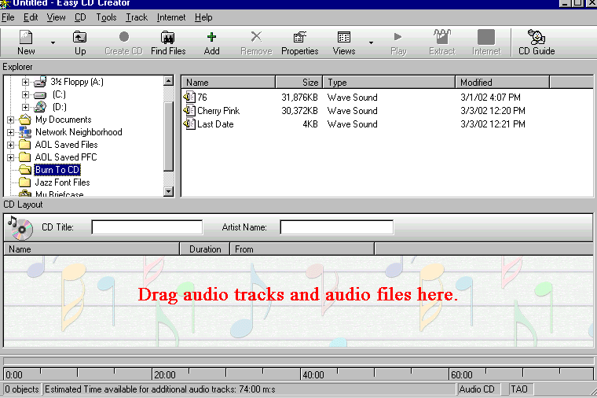
- As soon as I click on the folder called “BURN TO CD”, files will appear in the window that are available to burn to CD.

- The bottom box is where we are going to drag the music files so the burning software knows what files we want on our CD and in what order they should be.
- Note that at the bottom of the box it says ESTIMATED TIME AVAILABLE FOR ADDITIONAL AUDIO TRACKS 74:00 MNS. If you have a blank disk that is 80 minutes long instead of 74, double click on those words to bring up the pop-up box. In the pop-up box, click on ESTIMATED TIME 80 MINUTES. This will give you a more accurate time frame of how much space is left on your disk for recording. If you don’t do this, the disk will appear full before it really is.

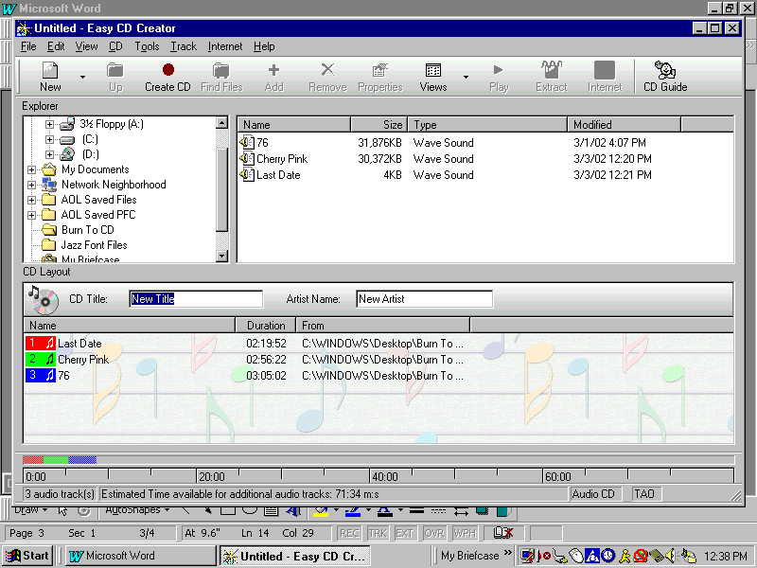
- Now, go ahead and drag your files from the top box to the bottom box. To do this, click on the file and hold your mouse button down as you drag it to the bottom box. Drop it anywhere in the bottom box. Below is an example where I have dragged three files into the bottom box.

- Ok, now we have our files where they belong. But, I have a problem – I changed my mind on the order I want to burn them to CD. No problem. Just click on the file and hold your mouse button down as you drag it to the new position. Drop it in the new position, and the software will put your songs in the new order.

- Now that we have our songs ready to record, our next step is to put a blank CD in our CD Burner. Do it now.

- Before we burn, I want to get one message across so you don’t ruin your first CD. If we use a blank CD-R disk, we can NOT CLOSE the CD if we intend to put more songs on the disk. Right now I have 3 songs in my line-up that I want to burn to CD. These 3 songs will NOT fill up the CD. So, I have to be especially careful that I don’t select an option that will close the CD. (You can close the CD, but just be aware that the songs you burned to the CD will always be the only songs on it.) If you are anything like me, the first one I did only had one song. I did that on purpose because I was so anxious to hear what it sounded like on my stereo and I did not know that there was an option that would allow me to hear it on my stereo if it wasn’t closed. This is one of the advantages of the newer versions of this software! Another thing you need to be aware of is that a CD-R disk that is not closed can NOT be played on any CD player/or stereo system unless it is recorded using the correct option. (See note at end of training about this!)

- Now, we are just a few clicks away from creating our first CD! In order to start the recording process, I need to click on the CREATE CD button.

- This brings up the screen where I make some important choices. But first I have to understand what each selection means before I can make an intelligent choice. On the screen where I make my choices is a HELP button. Click on that HELP button and read the information so you are well informed what the choices mean. For the purpose of this training, I am going to make choices for you that will record your songs to the CD; not close the CD out; close the recording session; leave a space between each song of 2 seconds; will allow you to add to the CD at a later date; plus hear the songs you have recorded on your stereo system.

- Here is the HELP Button! Make use of it!
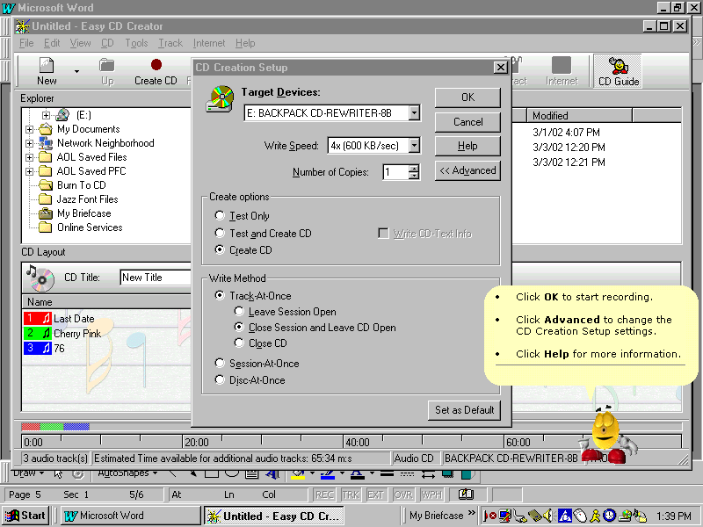
Note that in the CREATE OPTIONS, I can select to Test Only, Test and Create CD or Create CD. I have chosen to CREATE CD.
- Under the WRITE METHOD, my first selection is TEXT-AT-ONCE. I have chosen this because it puts a 2 to 3 second delay on the track between the songs.

- My next selection is CLOSE SESSION AND LEAVE CD OPEN. This means that I will be able to add more songs to this CD at a later date. It also means that I will be able to play the songs on my stereo system even though the CD isn’t closed. When I have the CD full, I will change my selection to CLOSE CD.

- 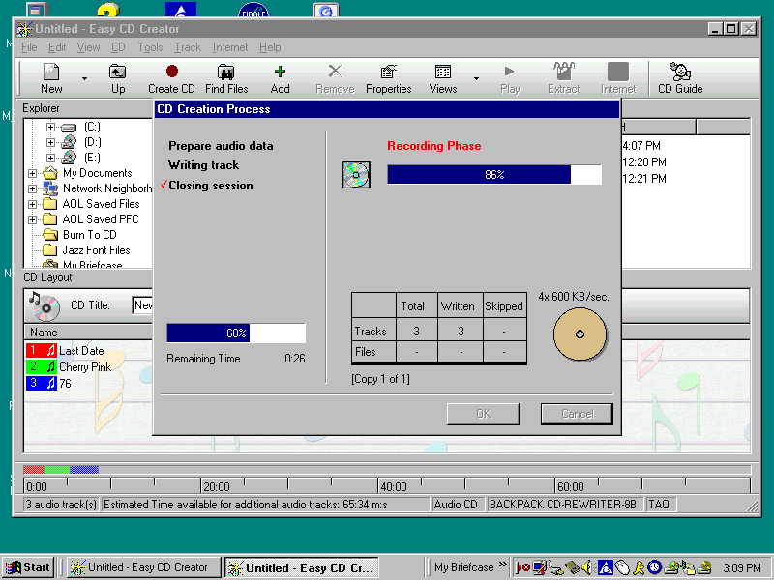Now all we need to do to begin the recording process is to click the OK button. Go ahead and click it and watch as your CD Burner does it’s thing. You will be able to monitor the recording process on your computer screen. The monitor looks like this:

- Towards the end of the recording process, the door to your CD Burner may open automatically and the tray will come out and then automatically go back in. This is normal. Do not try to take the CD out at this point.

- When you get the message CD CREATED SUCCESSFULLY on your monitoring screen, you may remove your CD.
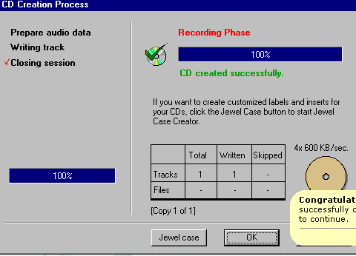
- Click on OK.

- The next item that will pop up on your screen is the dialog box that wants to know if you want to save your layout. If you intend on burning a duplicate CD of the same material, answer YES. This means that the next time you wish to burn another CD with these same songs on it, all you have to do is call the layout up again and then immediately start burning. If you answer NO, you will have to rebuild the CD layout before you can record it again. The choice is yours!
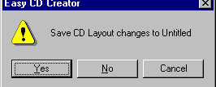

One of the things I failed to mention is that you can name your layout and put an artist name to the layout. Look for the fields on the screen where we build our files for the CD. They are located between the two sections of screen that show us what files are available in our computer to burn to CD and where we drag the files to get them on our CD. I am sure you can find it by yourself and type the title and artist name.

ANOTHER IMPORTANT NOTE: After I was through building this training, I discovered that you are only allowed to burn music to a CD without closing the CD one time and still be able to hear the songs on your stereo system. The next time you burn, you either have to close the CD or settle for not being able to hear the songs on your stereo until you are ready to close it. IF YOU DO NOT CHOOSE TO CLOSE THE CD, YOU CAN PLAY IT ON YOUR COMPUTER. IT WON’T BE THE SAME AS MOST SOUND CARDS ARE NOT AS HIGH QUALITY AS THE SPEAKERS FROM YOUR STEREO SYSTEM.

